Guided Practice Report
Before completing this guided practice report, you should have completed the associated procedure.

Screenshots
After you have completed the procedure for the guided practice, add your screenshots below.
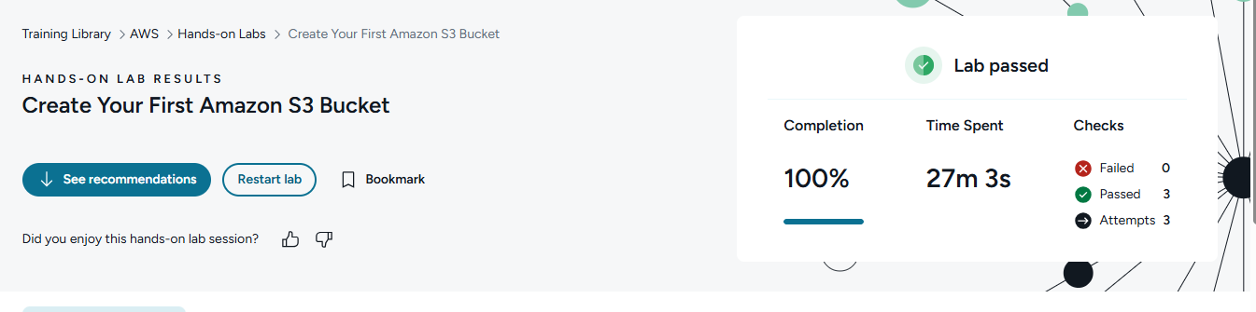

Reflection Questions
After you have completed the procedure for the guided practice, provide your answers to the reflection questions here.
As you were unchecking the Block all public access option, why were you required to manually type in confirmation word?
I had to type the confirmation word because turning off “Block all public access' is a risky security change. AWS wants to make sure you understand the bucket could become publicly accessible.

Toward the end of the lab assignment, why were you not allowed to delete the S3 bucket you created? What steps did you have to perform in order to delete your S3 bucket?
To delete the bucket, I had to:
- Open the S3 bucket.
- Delete all objects/files inside the bucket.
- If versioning was enabled, delete all object versions and delete markers too.
- Return to the bucket list.
- Select the now-empty bucket.
- Choose Delete.
- Type the bucket name to confirm deletion.
In short: AWS had me confirm public access changes for safety, and it blocked bucket deletion until the bucket was fully emptied first.

